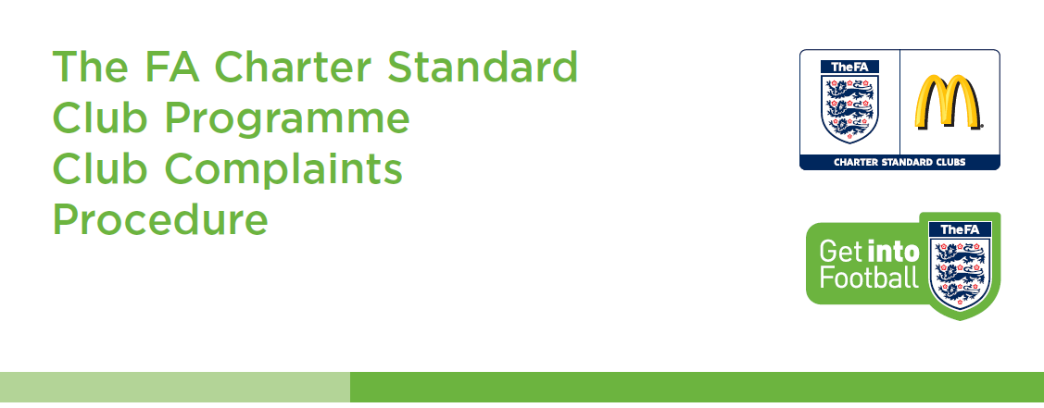
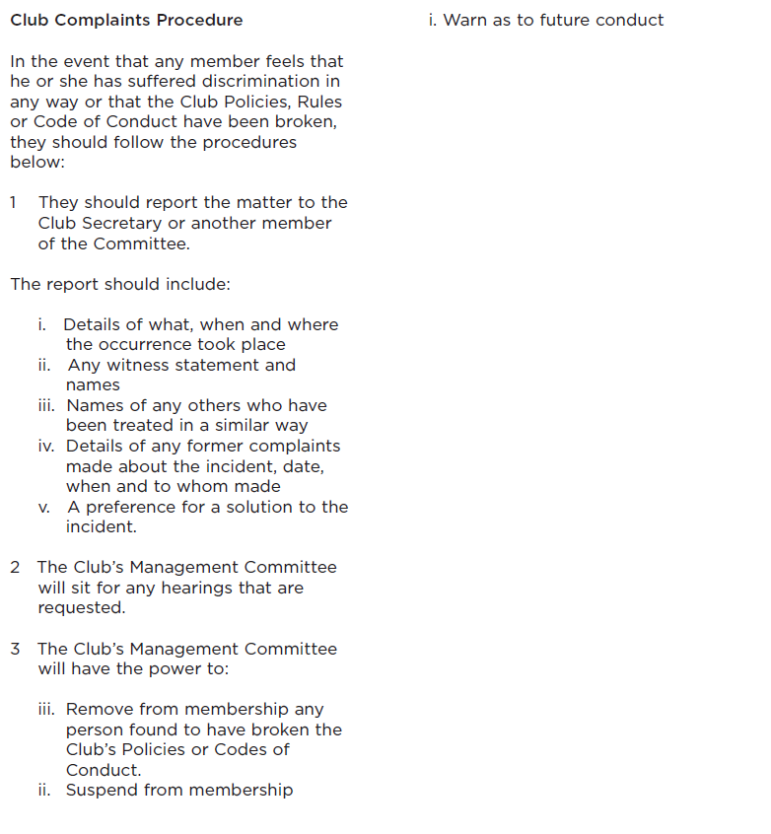

It is recognised that in any football club, differences and misunderstandings may arise. Successful resolution of differences depends on the willingness of the parties involved to communicate with one another. Every effort should be made to resolve disputes in an informal manner whatever issues arise. However, there will be occasions where issues cannot be resolved informally.
It is the policy of Ware Youth Football Club to provide an orderly and formal procedure to deal promptly and fairly with any serious differences of opinion.
Informal Procedure
• Discuss the complaint with the aggravator and seek a resolution as soon as practical.
• Where no satisfactory solution is possible, initiate a formal Grievance procedure.
Formal Grievance Procedure
As soon as practical, issue a description of the complaint in writing to the Ware Youth Football Club Chairman.
• The grievance must state the alleged issue, and in your view a suggested resolution to the grievance.
• A Grievance Panel will be formed members of the Ware Youth Football Club Committee.
• The Grievance Panel will formally respond to the grievance and if necessary, request further information.
• Having heard all sides of the argument, the Grievance Panel will make a decision on how best to resolve the complaint. This decision will be communicated to all interested parties.
• Decisions on all grievances will be made within two weeks of the formal procedure being initiated.
Right of Appeal
• You have the right appeal against the decision of the Grievance Panel, this must be done within one week of the decision being made and in writing to the Chairman.
• An appeals committee will be formed consisting of three members of the committee that have not already been involved with the investigation.
• The decision will be communicated within 1 week from the appeal date.
• The decision of the appeal committee is final.

